(Approx. 465 words)

Nero 10 Multimedia Suite Platinum
By George Harding, Treasurer, Tucson Computer Society, AZ
November 2011 issue, eJournal
www.aztcs.org
georgehardingsbd (at) earthlink.net

The Suite has a number of applications bundled onto one CD-ROM. Installation takes almost one-half hour and 3 .7Gb of hard disk space. There are 17 applications in the package, but the bottom line is four basic functions are provided: Music, Video & Photo, Data and Tools. Nero StartSmart gives you access to all of these. One of the valuable tools is the series of Help files. These are accessed online and include a PDF file for each tool in the package. There are also video tutorials which show you in slow motion how to do a particular task.

The Backup tools allow you to save files or your entire computer image, and to restore either of these. The destination can be a disc, your hard drive, a removable medium or online. You can also verify that the backup is correct. You can do backups automatically or by schedule. The Autobackup service is $55 per year for 25Gb of space; there is a free trial for 3 months with 1Gb space.

The Music tools offer you the following: play or organize music files; rip and burn music; mix music and digitize LP’s and tapes, and edit and record music The Video & Photo tools give you the ability to create a video or a slide show, play back multimedia and to convert on-protected DVDs to various formats . The Media Hub is a portal to the various tools to accomplish these tasks.

The Data tools include Burn and Copy data, BackUp data, and Restore and Recover. Nero Express gives you step-by-step instructions to burn and copy CD and DVD disks, a process that is not always self-explanatory.

Nero’s Start screen
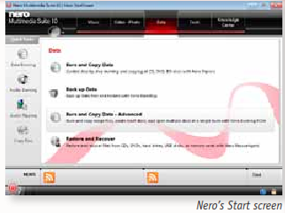
The Tools section offers a Performance test for your disk drives and System Configuration and Analysis to examine the setup and capabilities of your disks and software. The Performance test uses a blank disk and runs several tests to determine transfer rate, disk quality, CPU usage, burst rate and more. I tried the test on a CD. The process wrote 5,001 variable length records to the disk and saved the test results as well. The burn rate averaged 30.75X.

The System Config and Analysis does a rather complete analysis of your hardware and produces a report divided into Drive/Disk, Configuration (like Device Manager), software (only the Nero applications are listed), Drivers, Hardware, System (operating system, version and browser) and Hardware Readiness.

This is an extensive and complete system of applications and tools for you to deal with any operations involving data, music and disks. There is a 15-day free trial available.

About: Nero 10 Multimedia Suite Platinum
Vendor: Nero
www.nero.com
Price: ±$100

